Basic Principles of Electroacupuncture

RM Clemmons, DVM, PhD, CVA, CVFT
CAPT, IRC, USPHS (Veterinary)
Aso Prof of Neurology & Neurosurgery
University of Florida

Electrical acupuncture (EA) is a method which is very useful to provide more potent stimulation and predictable outcomes from acupuncture. In ancient China, EA did not exist; however, needle manipulation during acupuncture resulted in similar changes to EA. Now, EA is easier to perform than the old manipulative methods, so it is the method of choice in most cases. It is contraindicated in very weak (or old) patients (at least for the first treatment), but can be used gently once the reaction of the patient to dry needles (DN) is known. It is also contraindicated use EA across the ailing heart, across a pacemaker or through a cancer mass. In seizure patients, you should use it cautiously and probably only below CV8 until the impact of the acupuncture is known.
Initial EA therapies should probably be limited to 5-10 minutes to assess the response of the patient; however, the session can be extended in young, strong patients up to 20 minutes. Once EA is found to help the patient, then the sessions can be extended for 30-40 minute and the number of EA sites can be expanded from 3-5 electrode pairs used initially, to include all the areas where EA is needed. Practically, the initial treatment usually involves around 3 paired electrodes, while later the number of electrode pairs would be increased to 7. Moreover, initially, the method of stimulation is usually limited to only constant frequency simulation. In subsequent sessions, intermittent or dense-and-disperse methods will be added to some of the electrode pairs or as part of the EA session.

Basics of EA machine:

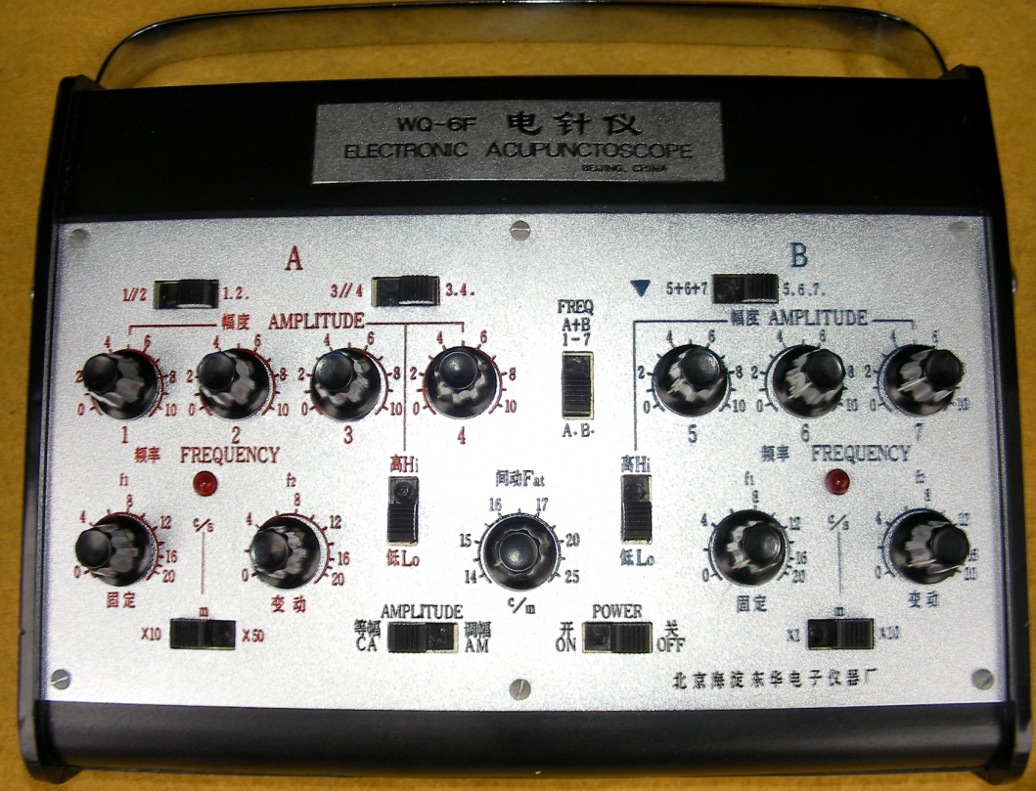
EA machine available from Jing Tang is a good basic example of most EA machines, although some features may be different among machines. The JT unit is very versatile so an explanation of the features it contains should explain the features of other EA units. Here we will discuss each row of buttons and eventually how to approach the EA patient.
The first row of buttons consists of 2 switches that determine the multiplying factor for the frequency so that the frequency knobs on each side are multiplied by 1 or 10. In addition there is an On/Off switch and a CA/AM switch. The On/Off switch is self explanatory; but you should get in the habit of turning all the knobs off before turning on the unit and you should turn the unit off at the end of the session and then turn all the knobs to zero. This helps prevent inadvertent over-stimulation of the patient. The CA/AM switch changes the unit from constant amplitude to modulated amplitude. For the most part, you will only want to use CA. However, AM might be useful in a patient who is very weak and you want to do some work similar to dense and disperse (DD) which we will discuss later. To use the AM function, start with CA and adjust the desired frequency and increase the amplitude until the patient shows deqi (and then back off slightly). Once this level is established, turn the switch to AM. You will probably only use the F1 knob to set the frequency you want and leave F2 at zero (we will explain these knobs momentarily). Again, AM is not as efficient as DD, but could be useful only in those patients where you want to try to achieve a “DD-like” effect and yet who cannot tolerate DD directly.
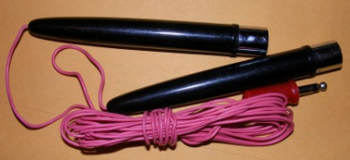
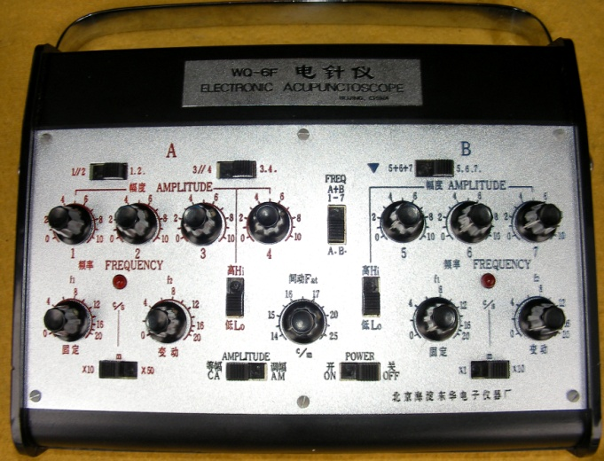
The second row of dials consists of 5 knobs and 2 switches. 2 knobs and 1 switch controls one set of outputs (four) on the left side and 2 knobs and 1 switch controls the second set of outputs (three) on the right side of the unit. The final knob in the center controls a special output to a set of electrodes which is used stimulate the skin directly using saline soaked cotton balls. This knob is also labeled FAT and controls the electrode output marked with w small triangle on the back of the unit. While this might be used in people, it has limited utility in small animals and so, I would recommend taping over it so that it would not inadvertently be used. It also makes sense to keep the FAT knob set at zero. So, while there might be special used of the FAT knob and electrode, your only concern is probably not to use it.
The Frequency knobs for each set of outputs are what you will adjust to perform most of the EA treatments that you use. The 2 knobs (on each side are labeled F1 and F2. F1 sets a constant frequency while F2 sets an intermittent frequency. That is, F1 sets a frequency which is always on, while F2 will go on and off for a period. If F1 is greater than F2, only constant frequency is delivered to the patient based upon the F1 setting. Usually when you want to set a constant frequency to the patient, you will set F2 to zero. If F2 is set higher than F1, then you will oscillate between F2’s frequency and that of F1. If F1 is set at zero, then the unit provides intermittent output at the frequency set by F2 which is called intermitted EA. This is a strong stimulation and might be more powerful than many small animals can tolerate. However, intermittent EA is a deep level procedure which drives the effects of EA to the deepest levels. A better compromise in small animals is DD. In this case F1 is set below F2 and so the oscillation between F1 and F2 is not so great as to disturb the patient. DD is also a deeper level technique, but not as strong as intermittent EA. The usual settings for DD are F1=80 and F2=120. Some people like F1=20 and F2=100 which produces both systemic AP and local analgesia, but this might be too great a difference in some animals. DD at 80/120 works at the organ level and is particularly good in paralysis as it provides a deep level massage.
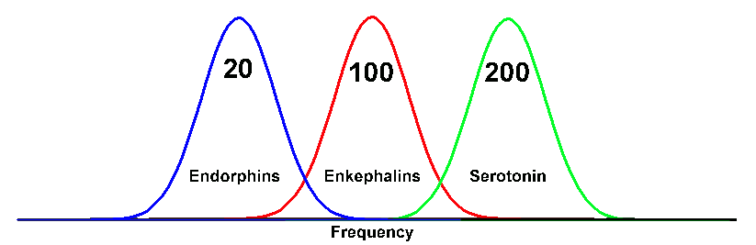
For the most part, we often use constant frequency utilizing only F1 and adjust the frequency based upon our goal to selectively change the neurochemistry of the patient to achieve our goals. Lower level stimulation from 4-40 Hz (centered around 20 Hz) primarily results in endorphin generation at the brainstem level and dynorphin generation at the local level. This produces analgesia which is similar to exogenous morphine and which is reversed by morphine antagonists such as naloxone. If the patient is on morphine, then low level stimulation may cross react and create tolerance between the morphine and EA. In some cases, this can actually decrease the effectiveness of both the morphine and the acupuncture. So, when patients are on opiate pain killers, EA should be done at the higher frequencies (for the most part closer to 200 Hz, since this will result in longer lasting effects than frequencies that favor only local enkephalins). The goal is to reduce the need for opiates through acupuncture, so that they can be replaced with EA alone.
The middle level frequencies around 100 Hz produce rapid, onset local analgesia through the production of local enkephalins at the spinal or brainstem nuclear level. This analgesia occurs quickly and also dissipates rapidly on cessation of the EA. However, this can be used to produce local surgical analgesia and does not interact with naloxone.
The higher frequencies (around 200 Hz) produce some enkephalins, but mostly also lead to serotonin release. This leads to descending neural control of segmental pain thresholds and also causes increase circulating serotonin levels to alter systemic pain thresholds. If post-surgical patients are on opiate analgesics, EA at higher frequencies results in prolonged analgesia while still providing EA anesthesia. It may be possible to perform some minor surgical procedures with sedation and EA which general anesthesia is not an option for the patient.
The 2 switches in this row go from low to high. This switch temporarily increases the output of the unit’s batteries so that any treatment being performed can be continued when the batteries are getting weak. So, the switch should be in the low position until the batteries are weakening and then only switched to high to help complete the treatment. Once switched to high it should remain there to remind you to change the batteries and then returned to low once the batteries are replaced. Since this will increase the output of the bank of electrodes, you should turn the amplitude down before switching to high and then re-adjust the amplitude based upon the animal’s de-qi response.
The next row of knobs (4 on the left and 3 on the right) control the amplitude of the outputs to the electrodes. Initially, they should be set to zero output. Once the unit is turned on, the frequency adjusted and the electrodes plugged in and connected to the patient, then the amplitude can be increased slowly intil the patient shows some evidence of de-qi. This might be a behavioral response of local twitching. If the de-qi is too high, then the amplitude should be reduced until the patient is comfortable. With fresh batteries, this is usually going to occur around “3”. If no de-qi is evident, then the electrodes or the unit’s batteries checked. The unit also comes with an audible tester which can be used to determine the output of the unit. It also can help demonstrate what you are doing to the client. This is also one way to help check the function of the unit. If the audible output is functioning, but no energy is being delivered to the patient on a channel, then it is probably the electrode that is bad. Of course, you can check electrodes with an ohm meter or you can try them on yourself.
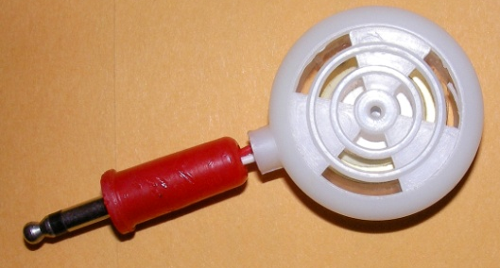
The last set of switches above the amplitude knobs are 2 switches on the left and one on the right. The set on the left controls paired outputs 1 & 2 and 3 & 4. The switches should be to the right. Switching to the left makes amplitude knobs 1 & 2 (or 3 & 4) interact together, so that altering either knob will affect the output of each channel. Generally, it is better to let each amplitude be set independently (switch to the right), since the de-qi of each electrode seems to be independent by nature. The switch on the right side of the unit controls channels 5, 6 & 7. If it is switched to the left, the energy of channel 5 is added to 6 and seven, while the energy of 6 is added to 7. Again, this is generally not very useful, so the important thing is that the switch is on the right, so that the channels are independent of each other.
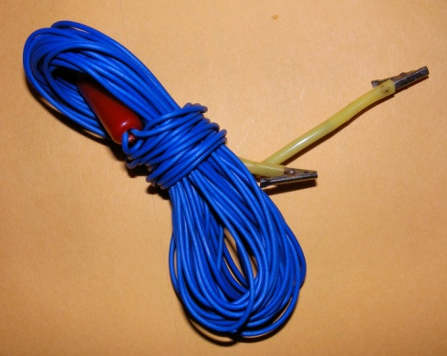
The electrodes are connected to the seven outputs in the rear of the unit. (Remember that there is the additional output for the FAT control which is not generally used). The electrodes have alligator clips which can be used to grasp the handle of shaft of the needle. The handle of most needles are wrapped with electrically conductible material which fits in the notch of the clip. While this can be used on the shaft of non-metallic handled needles, the connection is less secure. The electrodes for the Jing Tang unit are not polar. That is, they oscillate between positive and negative so that it does not matter which way they are attached to the needles. Some units have positive and negative poles and are connected according to whether the energy is directed one direction or another.
Electrodes are to the needles placed in pairs. These pairs may be along a meridian to treat or open the meridian. They may be placed across a lesion (such as connecting ST35 with BL40 to send the energy through the stifle). Electrodes may be used to cross the midline such as connecting the Hua Tou Jia Ji on each side of the spine. They can be connected from normal tissue to damaged tissue to being energy into the area such as using GV14 and Bai Hui to open the spinal cord. Finally, points with similar energy can be connected to augment the effects of treatment.
EA is effective and it makes pretty close AP more effective. While care should be taken in certain instances and it might be important to ramp up the treatments in old or debilitated patients, EA produced more pronounced affects over dry needles and lasts longer. Typically, the patient will receive constant stimulation based upon the desired neurotransmitters needed and then DD will be used to deepen the effects and work at a deeper level. When the treatment is over, turn the unit off and then return all the knobs to zero. The only switch I so not reset at the end is the low-high switch, since I turn that back to low once the batteries are changed. While other units may have different features, in general the principles of use are the same and this should still be a guide to using them, as well.

